The Grønli-Seter cave research project, Rana, North Norway

Stein-Erik Lauritzen, Hilde Hestangen, Sara M. Skutlaberg & Rannveig Øvrevik

Department of Earth Science
University of Bergen,
Allegaten 41, N-5007, Bergen, Norway

Abstract
The Grønli-Seter Cave Research Project (2001- 2005) is a multidiciplinary study of one of the longest caves in the country and also the most used tourist caves. The project was launched to accommodate the need for a proper survey and thorough knowledge of the system. The work was divided into three MSc. Theses, covering structural speleology, cave sedimentology and karst hydrology. The Grønli- Seter system, consisting of several separate caves now have an aggregate surveyed length of 8.2 km. This has led to detailed knowledge on cave morphology, structural and stratigraphic control, paleohydrology, stratigraphy and sedimentological fascies as well as details on aquifer behaviour, volume and present-day dissolution rate in the system. This makes the caves to the best surveyed and most thoroughly investigated caves in the country.

Introduction: the project
Grønligrotta at Mo i Rana, North Norway is one of the oldest known caves in the country. The first professional account of the cave was in 1875, and the first survey published in 1914 (StPierre, 2003). This cave is also the oldest tourist cave in the country and also the only existing commercial cave with electric light and footpaths, attracting about 8,000 visitors per year. Later, the nearby cave Setergrotta was surveyed by Horn (1947) and later Langgrotta-Isgrotta was added to the company (Grønlie 1980). Cave sediments of Grønligrotta were investigated by StPierre (1988) and Løvlie et al. (1988). On this background, the project was launched as a ‘total survey enterprise’, shared between the authors, the maps served as an accurate basis for detailed studies of structural spelology (Skutlaberg 2003), hydrology (Øvrevik 2002) and cave sedimentology (Hestangen 2005).

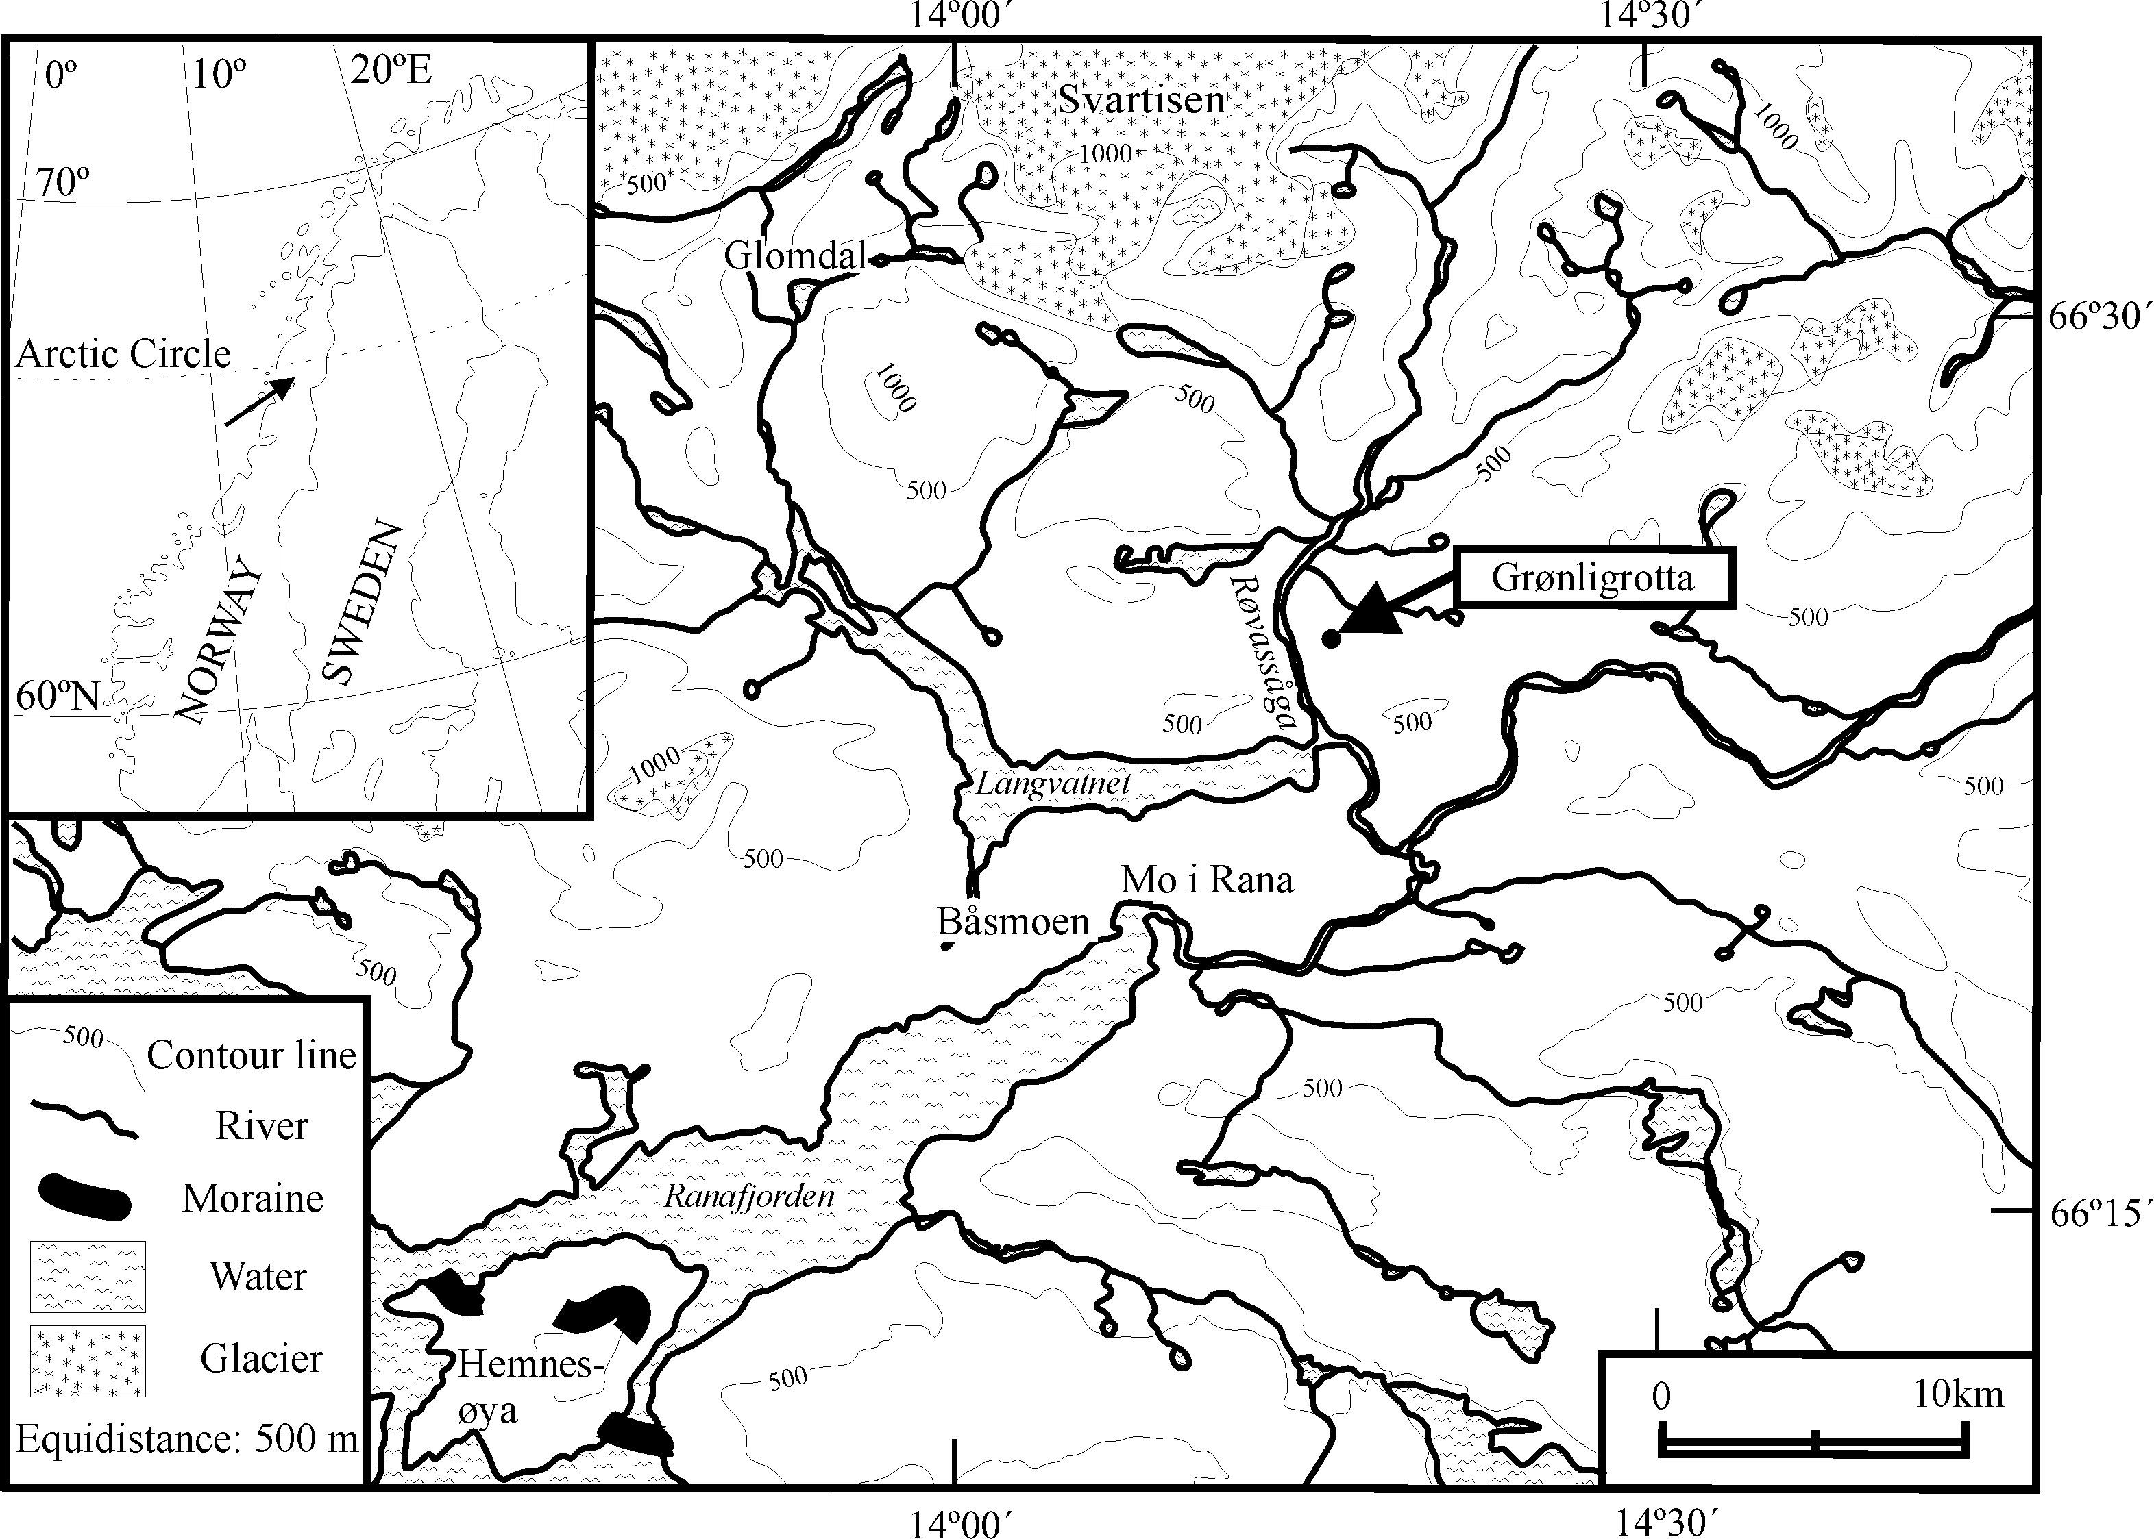 | 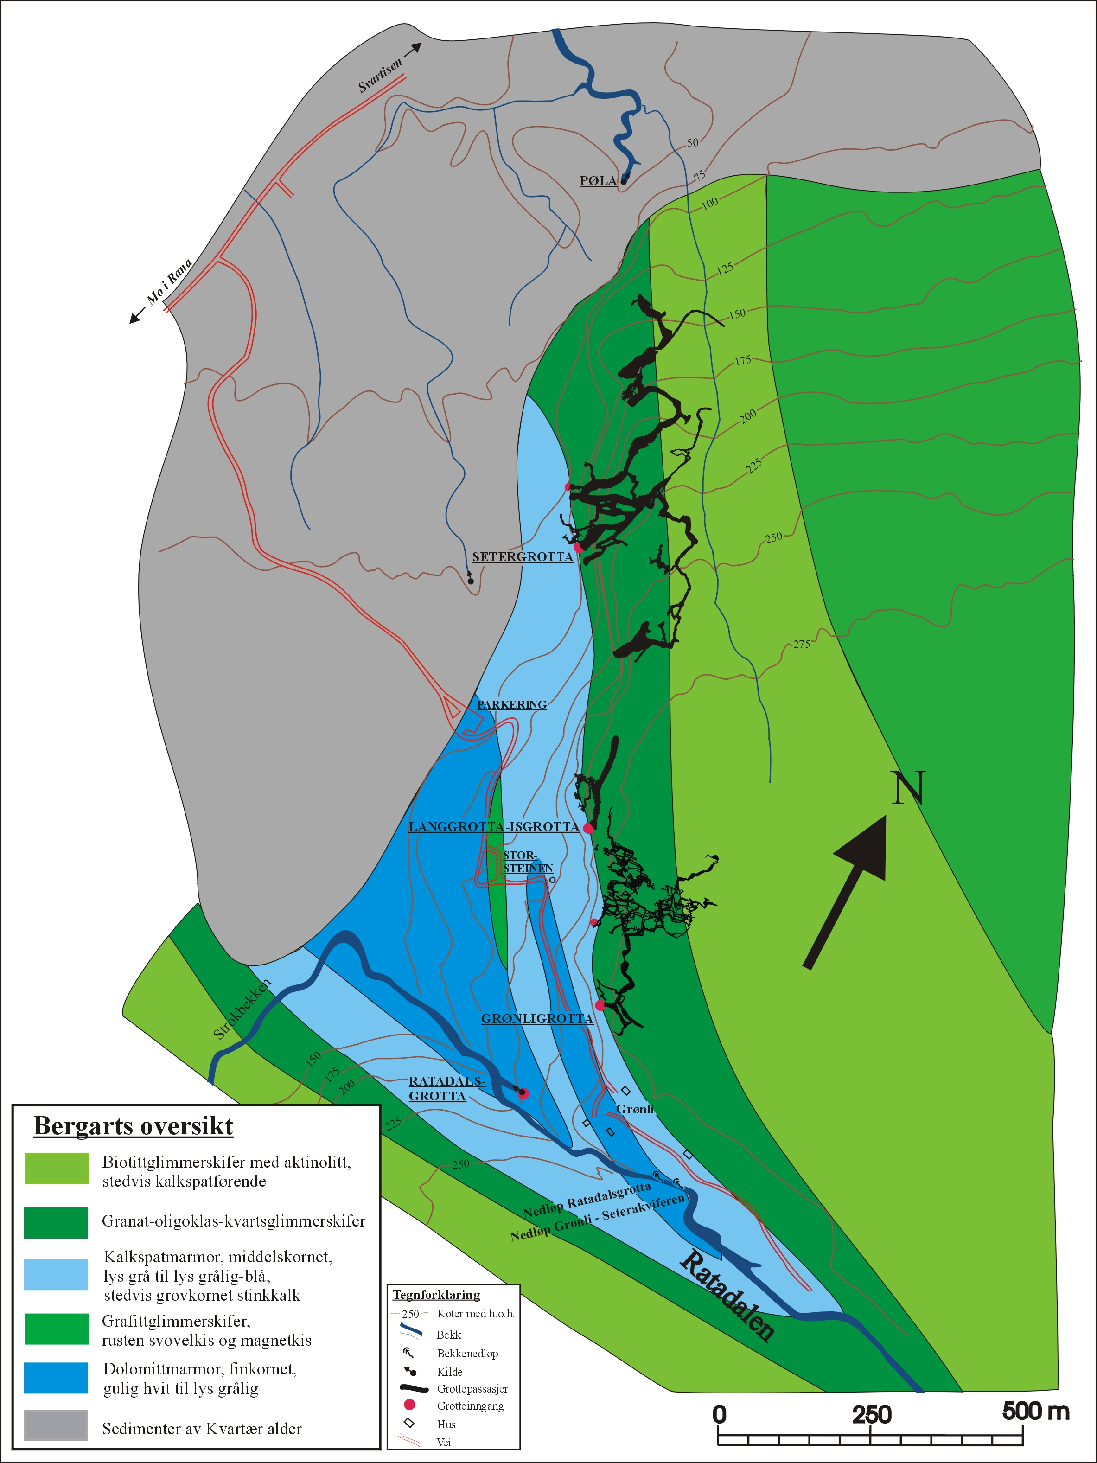
Figure 1 (above). Location and topographic setting of the Grønli caves in Rødvassdalen at Mo i Rana, N. Norway

Figure 2 (right). Simplified geological map of the recumbent fold containing the caves. See text forfurther discussion.

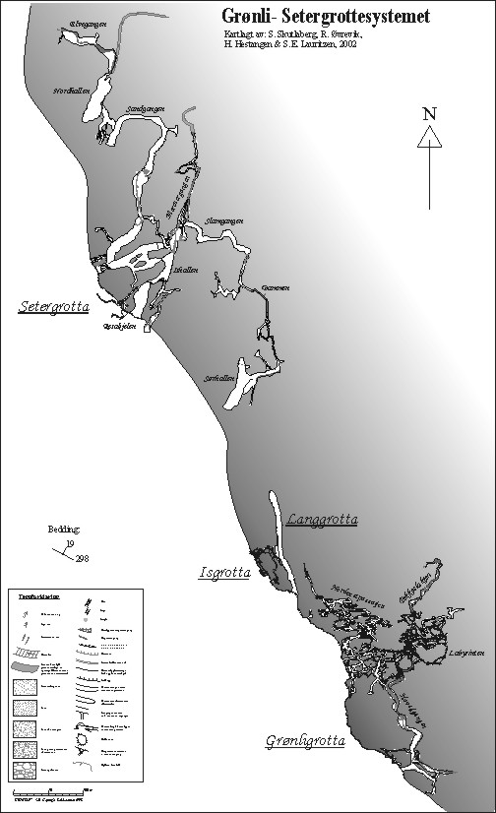 | Figure 3.  All Caves In The Grønli-Seter System, except extensions in Setergrotta done in 2003, i.e. ‘Det Forjettde Land’, which reduces the horizontal distance between Langgrotta and Setergrotta to about 40 m.  Proper reference to this map is: Skutlaberg,S.M.; Øvrevik,R.; Hestangen,H. & Lauritzen, S.E. 2002: “Grønli- Setergrotte systemet Cave map”.

Location and setting
The caves are all located in the wall and shoulder of Rødvassdalen at Mo i Rana, north Norway, a Glacial through that leads directly out from the Svartisen ice cap, Figure 1. The caves are located in bands of calcite and dolomitic marble belonging to the Rødingefjell nappe complex (Søvegjarto et al. 1989). The caves are located near the mica schist contact in the upper limb of a recumbent fold, Figure 2. Thus the caves are confined under a dipping (19ºNE) mica schist contact and are of Morphotype B (‘Low dip phreatic network or maze’) in the stripe karst cave classification of Lauritzen (2001).

Cave surveying
The caves were surveyed to BCRA grade 5C by the use of compass, clinometer, tape and laser rangefinder, using photographic tripods as stations. Passage dimensions were measured at each station and detailed cross sections drawn, recording geologic structures like foliation and fractures. Occationally, the polygon survey was linked to fixed points on the cave walls which were marked semi-permanently by means of a steel awl. Survey data were processed on the cave survey program Grottolf (Lauritzen 2003). The projected centerline survey was exported as a HPGL file (*.plt) and imported to Corel Draw for addition of passage details, Figure 3. Speleometric results are listed in Table 1. In addition to the surveying done by the authors, additional explorational pushing and digging towards a connection of all caves has been done: Nedre Isgrotta (Solbakk, Lauritzen unpublished 2002) and new, upstream extensions of Setergrotta (‘Det Forjettede Land’, Lauritzen and others unpublished 2003).

Table 1
Speleometric data for the Grønli-Seter system
Cave | Length (m) | Depth (m) | Volume (m³)ª | comment
Grønligrotta | 4,100 | 110 | 12,290 | Complete 2002
Langgrotta-Isgrotta | 440 |  | 3,540 | Connected by survey, complete 2002
Nedre Isgrotta | 268 | 25 | - | Situated below isgrotta, 2002-2003
Setergrotta | 3,430 | 81 | 46,130 | Survey by 2003, including extension
Total | 8,238 | 234
ª Volume calculated from passage dimensions at each survey station, assuming rectangular cross-sections.

Structural speleology and paleohydrology (Skutlaberg 2003)

Structural geology
The present-day metasediments were folded and metamorphosed in the late Silurian, Caledonian orogeny with regional compression NW-SE. The stress direction was deviated around large granite bodies in East and South so that the marbles were folded around them and in Grønlia the compression was basically N-S creating the large recumbent fold structure which hosts the caves. A later E-W compression depressed the fold axis, so that the structure plunges to the SE (Figure 2). Some brittle-ductile shear planes seen in the caves are probably from this period. Later penetration of tonalithic magmatic dykes also penetrated the carbonate mass. A variable composition suggests different injection episodes, and they have been displaced by later shear movements. As aquicludes, these dykes display a pronounced influence on speleogenesis where they occur. Later fracturing in the brittle regime produced strong E-W and NW-SE striking, steeply dipping fault and shear planes. Neotectonic movements (NS) imply that some of the NE-SW shearplanes might have been activated as Riedel shears. Subsequent fracture systems developed as erosional unloading occurred and during the last, Tertiary uplift. Glacio-isostatic loading/unloading also opened fractures, basically by sheeting mechanisms closer to the surface.

Speleogenesis
Initial speleogenesis commenced along a pyrite-impregnated horizon at the upper marble-schist contact, and we propose pyrite oxidation and sulphuric acid corrosion as the first speleogenetic process, which is quite common in Norway (Lauritzen 2001). Such marble-mica schist contacts are often sheared, providing a primary void for attack by the oxidising fluids. The timing of cave initialization is difficult to set, but the oxidation demand a meteoric environment rather than hypogean, hydrothermal conditions. Paleocurrent directions based on scallop morphometry clearly demonstrate that all caves were in general effluent with phreatic flow towards S. Consequently, flow was uphill and can only be explained by subglacial hydraulic gradients (Lauritzen 1984), probably at stages when local ice-streams filled the adjacent valley. Speleothem dating in other caves in the region put subglacial scalloping back beyond 30 kyr (Lauritzen unpublished). Maze- and labyrinth morphology (Grønligrotta, Isgrotta and parts of Setergrotta) advocate epiphreatic pumping as the most probable speleogenetic regime (See Øvrevik & Lauritzen, this volume). The larger passages of Setergrotta and Langgrotta are developed along almost vertical, NNE-SSW fractures and in pattern they form a series of large phreatic loops in the inclined foliation contact (298º/19º NE), closely resembling the speleogenetic model for inclined bedding planes (Ewers 1982), see Figure 3. Late re-routing of drainage due to blockfall and sediment chokes can be demonstrated in some places, as well as gradual lowering of the watertable through schist and dyke barriers, creating epiphreatic conditions and flooding sumps. Later vadose curring is evident along the present-day streamway which forms an invasion passage

Dissolution rate as a stratigraphic tool
In spite of an extensive marble pack, the caves are clustered at the upper schist contact. Apart from pyrite impregnation in the schist ceiling and the magmatic veins, the marble also contain dolomitic horizons, so that a more extensive chemical control of the stratigraphic position of the caves at horizoms of high speleogenetic affinity cannot be ruled out from inspection alone. Therefore, the karst rocks were logged at great detail and investigated for chemical and mineralogical composition. In particular, we measured dissolution rates on rock tablets and powder in free-drift experiments at ambient, atomopheric P_{CO2} in order to determine dissolution rates at various stages of saturation. We propose that loss of ignition at 800º (expelling CO₂), dissolution in dilute HCl (total Ca- and Mg-carbonates) and kinetic properties are the best measures of speleogentic affinity. Over a stratigraphic distance of 150 m, of which the caves occupy the upper 30 m, intial dissolution rate and apparent time to saturation on powder runs show that the upper 75 m of the sequence has a higher speleogenetic affinity than the lower half. However, we did not find any preferential zone of neither purity nor dissolution rate that could explain the much closer clustering of passages (apart from the pyrite impregnation). We therefore suggest that the stratigraphic position of the caves is mainly a hydraulic effect; the cave was created in the phreatic zone, confined beneath the mica schist ceiling rock.

Stratigraphy and sedimentological fascies (Hestangen 2005)

Sedimentological fascies found in the caves
Except for the active streamways and some phreatic tubes, most of the cave floor is covered with sediments. Grain sized cover all ranges, from glacial clays to blocks. Stagnant, glacilacustrine fascies have been detected in a few places, the best section is at a high level in Grønligrotta, where paleomagnetic dating suggests lacustrine conditions at 8.9 – 9.5 kyr, under ice-contact conditions (Løvlie et al. 1988). Fluvial sand and gravel is the most common fascies, such sections contain numerous cut-and-fill structures, making lithostratigraphic correlation difficult even over short distances. Flood and levee-type deposits are found in the large, down-stream passages of Setergrotta, as well as the epiphreatic passages display parallel accretion of organic mud in the ceiling and walls. The most dramatic fascies found in the cave is the hjøkullaup fascies, represented by huge rounded boulder that are imbricated uphill in a sloping gallery. The blocks have median axes of about 3 m and equally large giant scallops or inverted potholes are eroded into the mica schist roof above the deposit, Figure 4. We ascribe these conditions to have occurred during deglaciations, when large amounts of water were available and ice-contact created phreatic conditions in the cave.

Uranium-series dating of flowstones covering sediments yielded mid- Holocene dates whilst several calcareous concretions (Höhlekrapfen) yielded isochron ages of mid-Weichselian age (28- 32 kyr). One of them were in direct contact with a sand sequence, Figure 5.

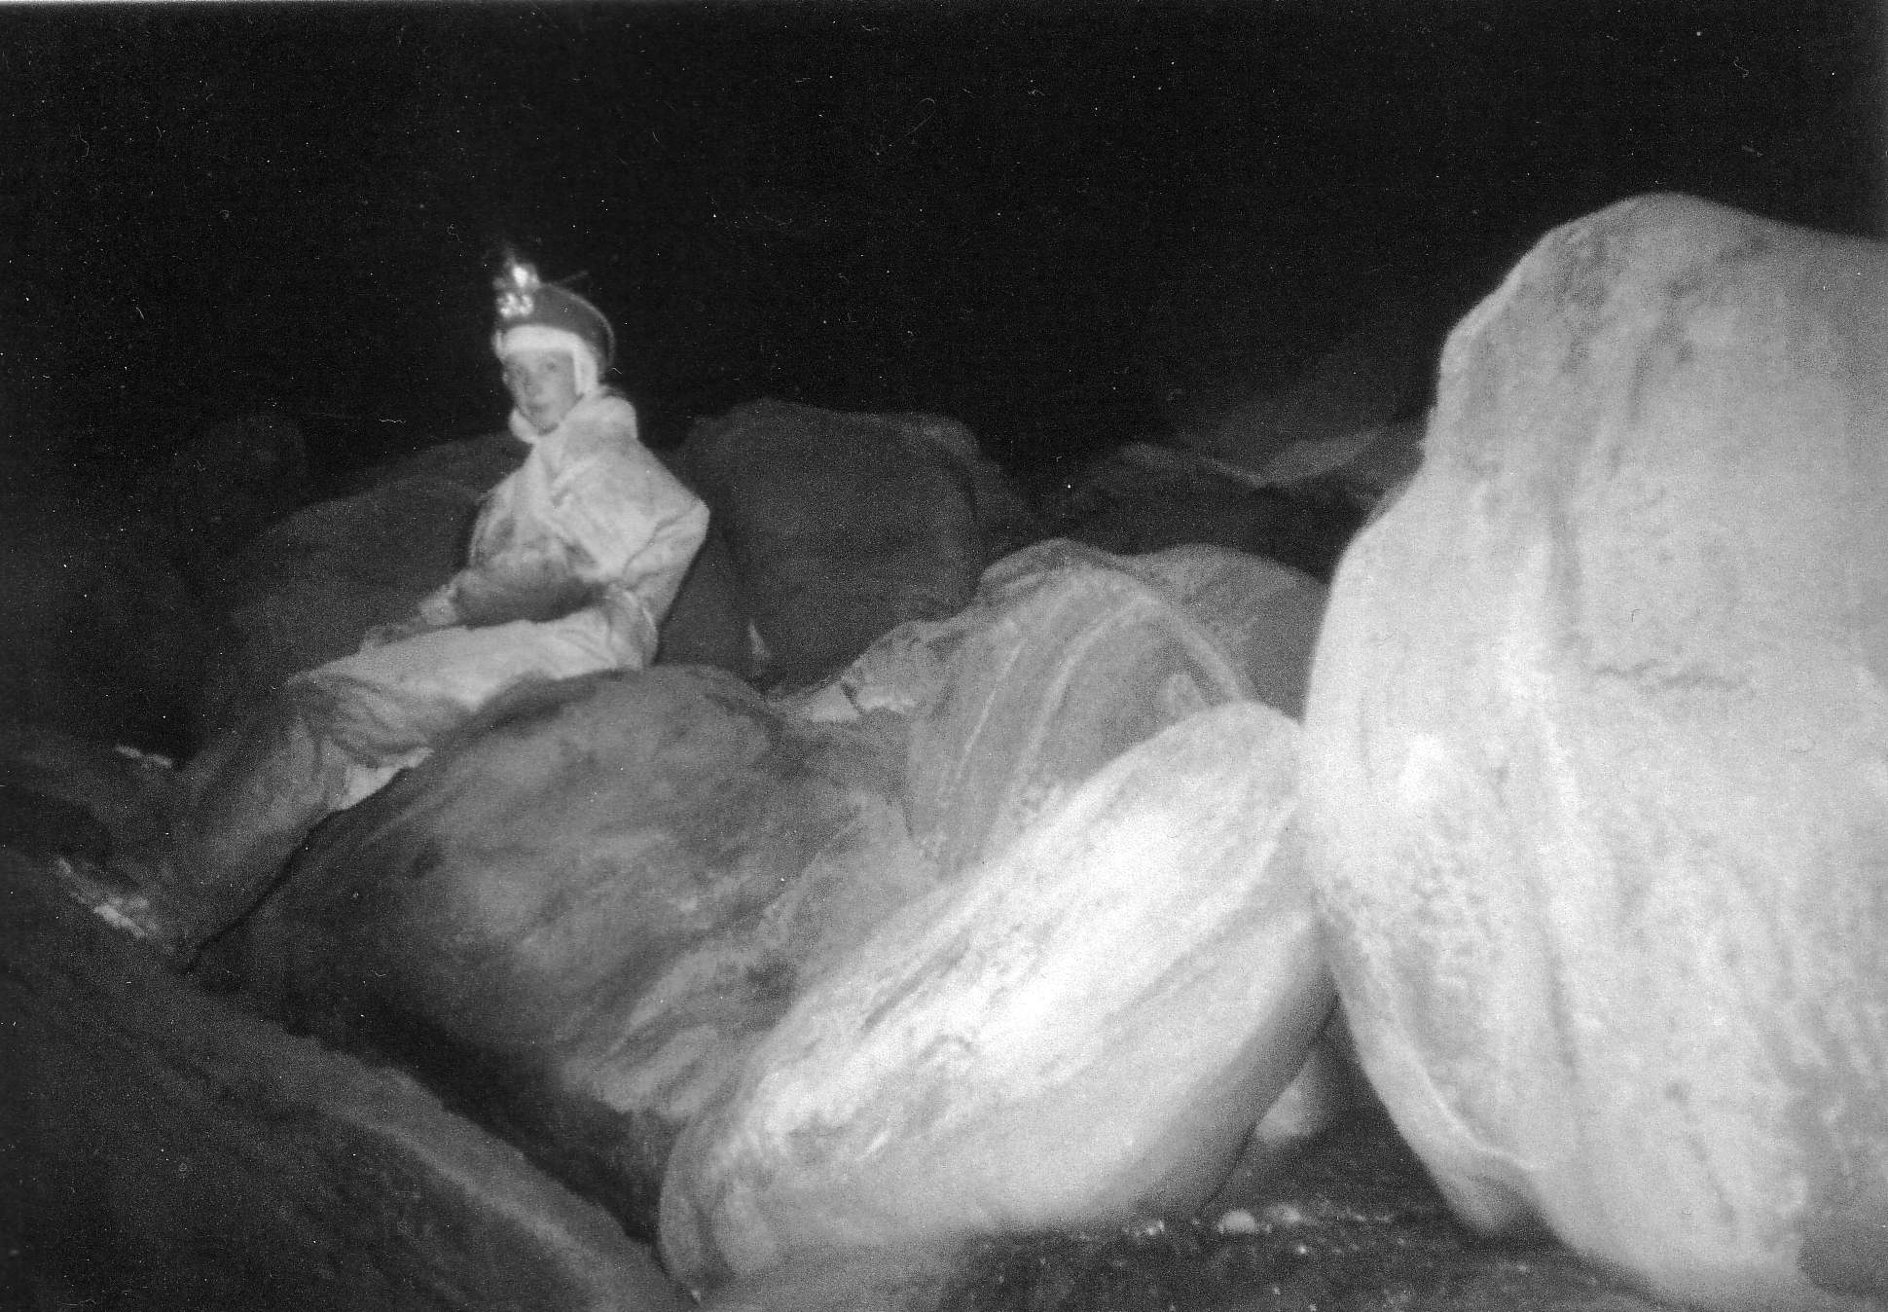 | 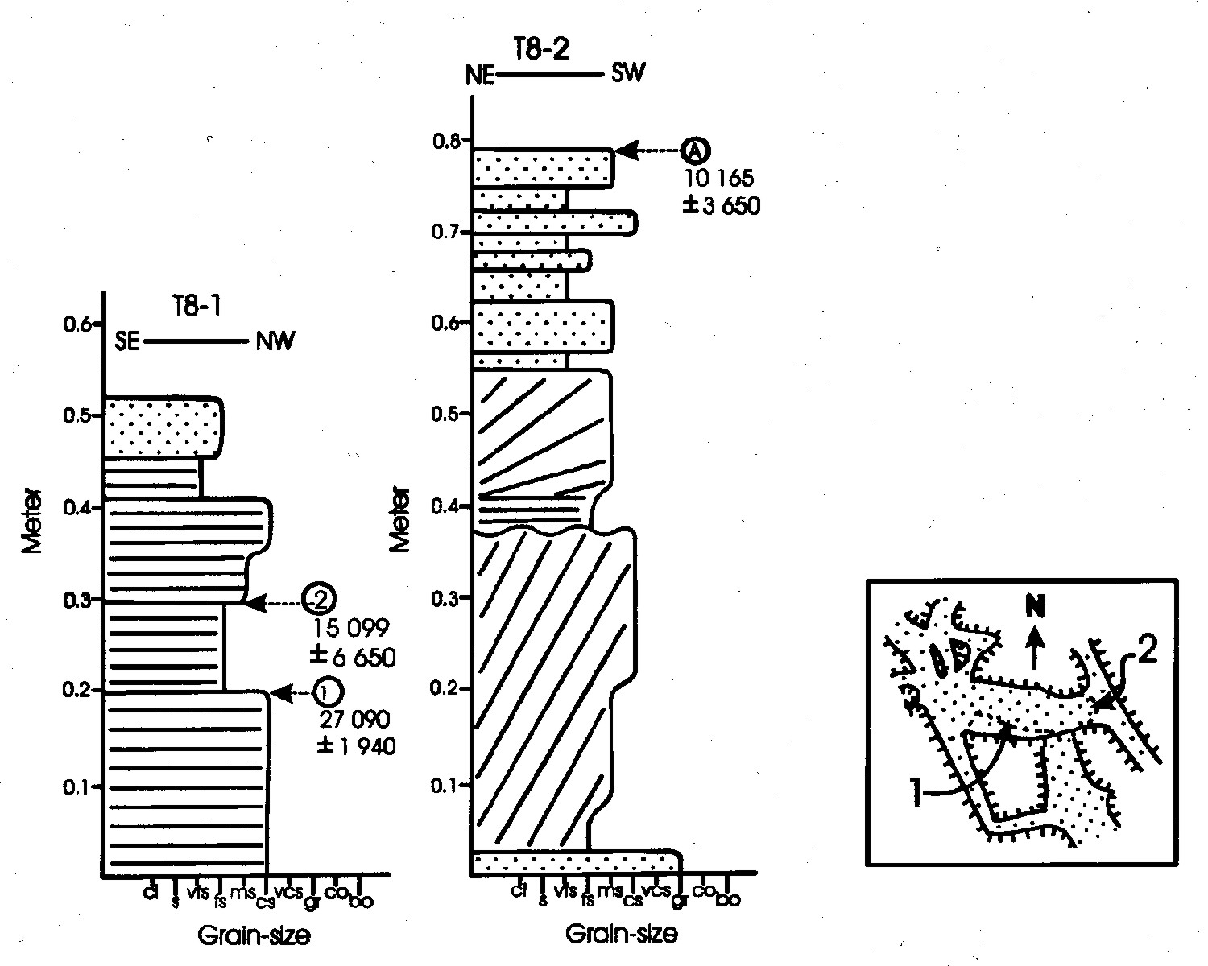
Figure 4. Hjøkullaup fascies in setergrotta. Rounded boulders imbricated uphill indicate enormous discharges out of the system. Photo S.E. lauritzen. | Figure 5. Sand sequence from Grønligrotta with calcite, u-series dated to 10, 15 and 27 kyr. From Hestangen (2005).

Hydrogeology and dissolution rate (Øvrevik 2002)

Methods
Stage, water temperature and electric conductivity were automatically monitored with sensors and data loggers at two stations; the cave inlet (Grønligrotta) and the main spring. Discharge was estimated by standard salt dilution method and stage-discharge curves were established. A systematic program of quantitative fluorometric dye tracing experiments was carried out by standard procedures using Rhodamine WT. Water samples were collected manually by conventional procedure.

Hydrologic measurements
Spring discharge, during the hydrological year 2000/2001, averages 130 ± 50 l/s, and can exceed 2000 l/s during storm flow. The lowest discharges appear during winter. From April to mid-June, discharge is dominated snow-melt. The aquifer modifies the hydrograph to a minor extent. Flood response is rapid and accompanied by sharp changes in chemistry and temperature. The specific conductivity in the spring (mean about 32 μS/cm) is significantly higher than in the cave inlet (mean about 24 μS/cm) due to dissolved CaCO₃. Water temperature in the Grønli-Seter aquifer is bimodal due to the sub-arctic climate. During winter, spring water temperature approach 3°C in stable periods while it in summer stabilizes at about 10°C.

Fluorometric dye tracing
The Grønli-Seter aquifer has single peaked breakthrough curves, relatively high recovery and insignificant difference in water discharge between sink and spring, indicating an aquifer with a rather simple conduit system and little dispersion. Volume estimates based on mean tracer transit time, are plotted versus distance in figure 6. There is a distinct change in gradient in the curve which seems to take place a few hundred metres downstream of Grønligrotta. In accordance with observations and mapping, the downstream, mostly phreatic parts of the system display a relatively high specific volume, about 4 m³/m, whilst the essentially vadose, upstream parts (i.e. Grønligrotta) display a much lower specific volume, about 1 m³/m.

Water chemistry
pH is slightly alkaline as common for karst water, ranging from 6.8 to 8.3. Bicarbonate, HCO₃⁻, and calcium, Ca²⁺, are the most abundant ion components in the system. They are positively correlated and concentrations increase through the aquifer. The aquifer also contains lower concentrations of magnesium, Mg²⁺. All three components are negatively correlated with discharge and positively correlated with specific conductivity. Other ions present are Na⁺, Cl⁻, SO₄²⁻ and K⁺. All water samples are strongly under-saturated with respect to calcite (and dolomite) with saturation indexes ranging between -1.1 and -3.3. The saturation index of calcite is significantly higher in the spring than in the cave inlet at the same discharge (two-tailed, paired t-test, p < 0.001). Water in the aquifer never reaches saturation, because the contact time between water and marble is too short to exploit the whole dissolution potential of the water.
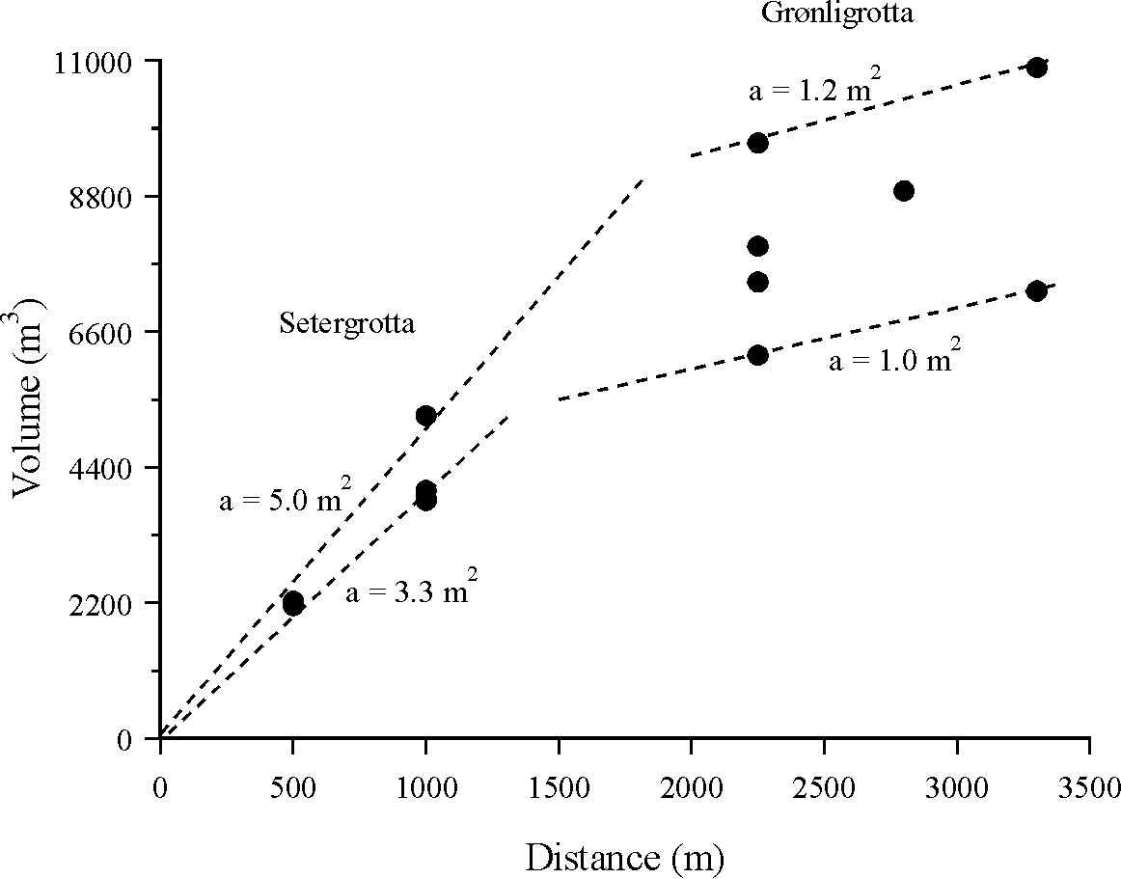 | 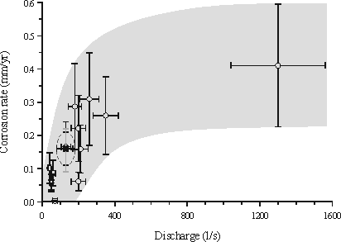
Figure 6. Aquifer volume shown as a function of distance from main spring. Volume estimates are based on mean tracer transit time. | Figure 7. Instantaneous chemical corrosion rates are shown as a function of discharge. In addition, mean rates based on mean annual run-off (broken circle) and chemical state (grey line) are plotted into the diagram.

Chemical corrosion rate
To make an estimate of the chemical corrosion rate in the aquifer we simplify calculation by making some assumptions. According to Palmer (1991), the rate solutional wall retreat, S, in a passage segment of finite length (L) and essentially constant cross-section can be estimated by the following equation:

$S=\frac{\text{31}\text{.}\text{56}Q(C−C_{0})}{\text{pL}ρ_{r}}$ (1)
where Q = discharge, C₀ and C are solute concentrations at the upstream and downstream end of the segment, respectively, p = wet perimeter and ρ_{r} is density of the carbonate rock (2.7 g/cm³). The coefficient 31.56 converts seconds to years, grams to milligrams and litres to cm³. The numerator is the transport rate of calcite, T, out of the passage. Mean annual run-off in the spring is 130 ± 50 l/s which yield a total annual transport of calcite between 7.7 and 14.2 metric ton, with a best estimate of 11.1 metric ton. The length of the aquifer is 2800 m. The vadose and phreatic parts of the aquifer have quite different mean cross-sectional areas, about 1 m² and 4 m², respectively. The phreatic part of the aquifer is about 1800 m long, while the vadose part is about 1000 m long. The wet perimeter of the phreatic part is estimated as a circle while the wet perimeter of the vadose part is estimated as three sides of a square. The perimeter of smooth cylinders turned out to underestimate the perimeter of irregular cross-sections by about 57 %. According to this relation the wet perimeter of the phreatic conduits will be 11.5 m, and for the vadose conduits 5.1 m. The best estimate of wall area exposed to corrosion is then 25 892 m². From equation (1) the chemical corrosion rate is calculated to range between 0.11 and 0.20 mm/yr, with a best estimate of 0.16 mm/yr. Instantaneous chemical corrosion rates have been estimated from total hardness in water samples and corresponding discharge measurements, Figure 7.

Acknowledgements
Logistic support, unlimited access to the caves and accommodation from Setergrotta A/S (P.G. Hjorthen) and from Grønligrotta (The Pedersen family) are gratefully acknowleged.

References.
Ewers, R.O. 1982: Cavern development in the dimensions of length and breadth. PhD. Thesis, McMaster University. 398 pp.
Grønlie, A. 1980: Grotter i Grønliflåget. Norsk Grotteblad 2(5), pp 22-30.
Hestangen, H. (Lauritzen, S.E) 2005: The Sedimentology of the Grønli-setergrotta cave sytem, Mo i Rana, Nordland, Norway. Cand Scient Thesis, Department of Earth Science, Bergen University. 190 pp.
Horn, G. 1947: Karsthuler i Nordland. Norges Geol. Unders. 165. 77 pp.
Lauritzen, S.E. 2001: Marble stripe karst of the Scandinavian Caledonides: and end-member in the contact karst spectrum. Acta Carsologica 30 (2) 47-79.
Lauritzen, S.E. 2003: Kompendium I Grottekartlegging. Grottolf2 og Grottolf3.2: et turbo pascal program til grottekartlegging. Norsk Grotteblad (39), 3-54.
Lauritzen, S.E. (1984) Evidence of subglacial karstification in Glomdal, Svartisen, Norway. Norsk Geografisk Tidsskrift, 38, pp. 169-170.
Løvlie, R.; Gilje-Nilsen, H. & lauritzen, S.E. 1988: revised magnetostratigraphic age estimate of cave sediments from Grønligrotta, Norway. BCRA Transactions 15 (3), 105-108.
Palmer, A.N. 1991: Origin and morphology of limestone caves. Geol. Soc. Am. Bull. 103, 1-21.
Skutlaberg, S.M. (Lauritzen, S.E.) 2003: Paleohydrogeologi, bruddgeometri og litostratigrafi I Grønli- setergrottesystemet, Mo i Rana. (Paleohydrogeology, fracture geometry and lithostratigraphy in the Grønli- seter cave system, Mo i Rana). Cand Scient Thesis, Department of Earth Science, Bergen University. 188 pp + I-XXVII.
StPierre, S. 1988: Morphology and sediments of the Grønli- seter caves, Norway. BCRA Transactions 15 (3), 109-116.
StPierre, D. 2003: Preliminary bibliography for Grønligrotta and Setergrotta, Rana, Norway. Norsk Grotteblad (40), pp14-19.
Søvegjarto, U.; Marker, M. & Gjelle, S. 1989: Storforshei 2027 IV, bedrock map 1: 50 000. NGU, Norway.
Øvrevik, R. (Lauritzen, S.E) 2002: Hydrogeologi og karstkorrosjon i Grønli-Seterakviferen, Mo i Rana. (Hydrogeology and karst corrosion in the Grønli-Seter karst aquifer, Mo i Rana). Cand Scient Thesis, Department of Earth Science, Bergen University. 169 pp + I-XI.

