MINERALOGY OF MINE CAVES IN SARDINIA (ITALY)

Jo De Waele (1)* and Paolo Forti (2)

(1) Dipartimento di Scienze della Terra, via Trentino 51, 09127 Cagliari, Italy geoam@unica.it
(2) Istituto Italiano di Speleologia, via Zamboni 67, 40126 Bologna, Italy forti@geomin.unibo.it

* corresponding author e-mail : geoam@unica.it

Abstract
An important mineralogical study has been conducted on the “mine caves” of Southwest Sardinia, Italy in the past two years (National Research Project COFIN 2001-2003). This research involved the Universities of Bologna, Modena and Cagliari and the IGEA (Geo-Environmental Projects) Society of Iglesias. The area is part of the "Geomining Park of Sardinia" recently instituted in a European framework
"Mine caves" are natural cavities formed in contact with or within mineral deposits, sometimes developing far below the present topographical surface, and generally lacking a natural entrance. Their access is possible through artificial excavations such as mine shafts and tunnels. At present more than hundred mine caves are known in the area.
Many specific morphological and mineralogical studies on speleothems from mine caves have been done in the past 20 years, but only recently these researches have been conducted in a much more organised manner. In some of these mine caves mineralogical and speleogenetical research has been performed comprising in situ analysis and observations (climatic and physical-chemical parameters) and sampling of minerals and speleothems.
The morphological and mineralogical analysis allowed not only to enhance the knowledge, up to date relatively scarce, on these special depositional environments represented by mine caves, but also permitted to increase the mineralogenetical knowledge of some rare minerals (especially, but not only, phosphates and sulphates). A short overview of all these minerals is given together with some morphological and genetical observations.
The scientific data obtained in this field of research will surely be of great practical use for the individuation of the most important areas of scientific and/or didactical interest inside the Geomining Park of Sardinia, areas which can be effectively protected and valorised. These researches will also be of immediate practical use for the definition of the territorial planning of the Geomining Park of Sardinia, allowing to identify both caves of great scientific interest that are extremely vulnerable and should therefore be adequately protected and eventually foreseen to become "scientific subterranean laboratories", and caves for which a didactic-tourist valorisation plan would be appropriate in the framework of a cultural development inside the Geomining Park.
In the near future a Monography on the “mine caves” of Mount San Giovanni, the most representative karst area of the entire Iglesiente mining district, will be printed with the aim to be the starting point for the development of similar studies in other karst areas in mine districts outside Sardinia.

Previous studies
Mine activities in Sardinia have started many centuries ago making of the Island one of the most important mine regions of Europe since Prehistory. Also Phoenicians and Romans extracted Ag-rich galena from the underground, mainly in South-Sardinia, and also in Medieval times this mineral remained the most researched mineral resource. But it is especially since industrial age that mineral exploitation grew exponentially in dimension and in space, scattering the territory with mine shafts, drafts and impressive underground workings. It is mainly in this period that mine works started intersecting and reporting natural cavities, the so-called “mine caves”, karst caves with no natural entrance and accessible only through artificial ways. Prevalently the mines of Southwestern Sardinia, in the Iglesiente-Sulcis region, have encountered many of those mine caves, because the Pb-Zn mineralization is hosted in well karstified Lower Cambrian limestones and dolostones. In 1888 the Grande Sorgente (1694 SA/CA) at Monteponi mine has been discovered at +7 m a.s.l. during the perforation of the drainage tunnel that connected this mine with the Sa Masa pond close to the sea at 8 km distance. This mine cave, of great hydrogeological importance, is one of the first to be often mentioned in official mine reports (Fabbri & Forti, 1981; Civita et al., 1980; 1983). Another important mine cave, discovered in the early XXth century, is Rolfo cave (1301 SA/CA), close to Domusnovas, described in a report written by a mine engineer as “very well decorated and multi-coloured”. At present more than hundred mine caves are known in the Iglesiente-Sulcis area, most of which are located in the following mines: San Giovanni, Monteponi, Campo Pisano, Masua, Acquaresi and Barega at Iglesias, Santa Lucia, Gutturu Pala and Su Zurfuru at Fluminimaggiore, Rolfo, Perda Niedda, Sa Duchessa and Barraxiutta at Domusnovas, Monte Onixeddu at Gonnesa-Carbonia and Caitas at Buggerru (Fig.1).
The mineralogical interest of these mine caves has been treated only since recently, exception given for a few papers regarding cerussite stalactites in Arenas mine (Uras, 1957), barite crystals of the famous Santa Barbara mine cave (Rossetti & Zucchini, 1957; Forti & Perna, 1981) and blue aragonite from Crovassa Azzurra at San Giovanni mine and some other natural karst caves (Cervellati et al., 1971). More systematic studies have been carried out in the period 1979-1982 in the framework of a European Project (Contract CEE CREST 114-79-7-MPP I) aimed to the definition of the hydrogeological parameters of the water circulation in the carbonatic mine areas. During these researches many mine caves have been documented and studied (Forti & Perna, 1982a) and mineralogical samples taken during these campaigns have allowed to publish many articles on cave minerals and speleothems during the following 5 years, reporting many new mineral species for the cave environment such as Bianchite, Monteponite (Forti, 1985; Forti & Perna, 1988), melanterite (Bini et al., 1986), gaspeite (Cadoni et al., 1986) besides other more common cave minerals such as calcite (Forti et al., 1981; Forti & Perna, 1982b; 1982d), aragonite (Forti & Perna, 1982c; 1983) and many others (Hill & Forti, 1997).

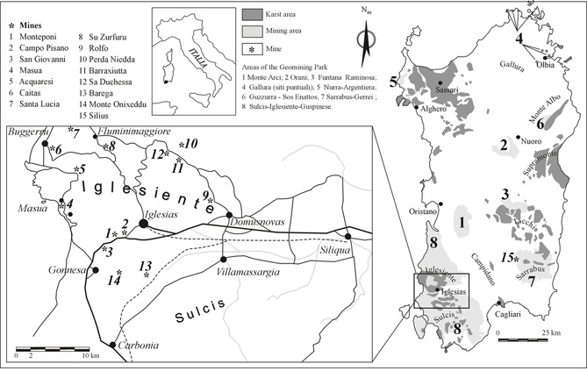
Fig. 1 – The Geomining Park of Sardinia, the karst areas and the main mines of speleological interest

Papers have also been published on fluid inclusions of quartz, barite and calcite from mine caves, allowing to better understand the genesis of ore deposits and gangue minerals ( De Vivo et al., 1987; Cortecci et al., 1987; Ludwig et al., 1989), on cave sediments and palaeokarstic fills (Bini et al., 1988), on hyperkarst phenomena (Forti & Perna, 1986; De Waele et al., 2001) and on cave morphologies (Forti & Perna, 1982b; Fabbri & Forti, 1986; Chiesi & Forti, 1987) enabling to make more detailed speleogenetical observations.
With the beginning of the debate on the institution of the Geomining, Historical and Environmental Park of Sardinia, recognised by National Law in October 2001, sporadic research has permitted to discover some new mine caves of scientific interest (De Waele et al., 1999), including the Quartziti cave (2469 SA/CA) in San Giovanni mine with its hemimorphite flowstones (Forti et al., 1999).
Recently, a new impulse on cave mineral studies has been given by the Italian National Project PRIN 2002-2004 “Morphological and mineralogical study of speleothems for the reconstruction of particular karst environments” (Resp. Paolo Forti) during which many new mine caves have been visited and explored (De Waele et al., 2003; De Waele et al., 2004a; 2004b; De Waele & Frau, 2005), leading to the discovery of a whole set of new minerals, further enriching the already long list of cave minerals of the Sardinian mine caves (Forti, 2005; Forti et al., 2005a; 2005b; 2005c).

Cave minerals of Sardinian mine caves
In this short paper the Authors resume the knowledge on cave minerals in the Sardinian mine caves. A list of cave minerals reported from Sardinian mine caves is reported in Table 1. Cave minerals are secondary minerals derived by physico-chemical reactions from a primary mineral in bedrock or detritus. A cave mineral is formed because of a unique set of conditions within the cave environment (Hill & Forti, 1997). The paper deals only with these secondary cave minerals, excluding thus all those minerals that can be found in caves but that haven’t been formed in this peculiar environment. In fact, many minerals that were present in the host rock before the cave was formed or have been transported from outside are not considered as “cave minerals”.

No native elements are known in Sardinian mine caves, even though the presence of sulphur should not be excluded. Sulphur, in fact, can be produced in caves by the oxidation of pyrite, that often occurs in the host rock and has also been described from small mine caves in the Silius barite-fluorite mine (Forti, 1983). Abundant sulphides that occur in many mine caves of Sulcis-Iglesiente are galena and Sphalerite, respectively lead and zinc sulphides. Both minerals have been found in karst caves intercepted by the underground workings of many mines (Hill & Forti, 1997) and galena sometimes fills paleokarst conduits entirely, demonstrating post-depositional remobilisation processes (Forti et al., 2005b; 2005c). In small caves discovered in the Silius mines and Santa Lucia mines (Fluminimaggiore) fluorite occurs in crystals of up to 1-2 cm. Fluorite is formed by deposition from hydrothermal fluids that circulate in the karst voids (Forti, 1985). Many oxides and hydroxides occur in Sardinian mine caves, such as the common minerals Hematite, Goethite and Gibbsite, but also very rare mineral species such as Monteponite (Forti & Perna, 1988), Coronadite (?), Heterolite and Hydroeterolite, Chalcophanite, Cesarolite (Forti et al., 2005c) and Brianyoungite (Fig. 2a and c) (Forti et al., 2005a). These minerals usually occur inside the terra rossa sediments, produced by the oxidation of primary sulphide deposits, and are deposited in karst pockets.

Tab. I – Minerals of cave mines in Sardinia

Mineral | Chemical Formula | Crystal system | Locations
Sulphides
Galena | PbS | Isometric | Many localities
Sphalerite | ZnS | Isometric | Masua, Monteponi, C. Pisano, S.Barbara
Pyrite | FeS₂ | Isometric | Silius
Halides
Fluorite | CaF₂ | Isometric | Silius, Santa Lucia
Oxides/Hydroxides
Monteponite | CdO | Isometric | Monteponi
Coronadite (?) | PbMn₈O₁₆ | Monoclinic | S.Barbara
Hematite | α-Fe₂O₃ | Monoclinic | Perda Niedda
Heterolite | ZnMn₂O₄ | Tetragonal | S.Barbara
Hydroeterolite | Zn₂Mn₄O₈·H₂O | Tetragonal | S.Barbara
Chalcophanite | ZnMn₃O₇·3H₂O | Trigonal | S.Barbara
Cesarolite | PbMn₃O₇·H₂O | Hexagonal ? | S.Barbara
Goethite | α-FeO(OH) | Orthorhombic | Perda Niedda, S.Barbara
Brianyoungite | Zn₃(Co₃SO₄)(OH)₄ | Orthor./Monocl. | Su Zurfuru
Gibbsite | γ-Al(OH)₃ | Monoclinic | Perda Niedda
Carbonates
Aragonite | CaCO₃ | Orthorhombic | Almost all locations
Calcite | CaCO₃ | Trigonal | Almost all locations
Cerussite | PbCO₃ | Orthorhombic | Many localities
Dolomite | CaMg(CO₃)₂ | Trigonal | Almost all locations
Smithsonite | ZnCO₃ | Trigonal | Masua
Siderite | FeCO₃ | Trigonal | Monteponi
Phosgenite | Pb₂(CO₃)Cl₂ | Tetragonal | Monteponi
Hydrozincite | Zn₅(CO₃)₂(OH)₆ | Monoclinic | Albert 7, Su Zurfuru
Aurichalcite | (Zn,Cu)₅(CO₃)₂(OH)₆ | Monoclinic | San Giovanni
Gaspeite | (Ni, Mg, Fe)CO₃ | Trigonal | San Benedetto
Arsenates
Ediphane | Ca₂Pb₃(AsO₄)₃Cl | Hexagonal | S.Barbara
Sulphates
Barite | BaSO₄ | Orthorhombic | S. Lucia, Silius, Barega, Su Zurfuru, S.Barbara
Anglesite | PbSO₄ | Orthorhombic | San Giovanni, Monteponi
Gypsum | CaSO₄.2H₂O | Monoclinic | Montevecchio, Su Zurfuru
Melanterite | FeSO₄.7H₂O | Monoclinic | Montevecchio, Genna Luas
Siderotile | FeSO₄.5H₂O | Monoclinic | Montevecchio, Genna Luas
Copiapite | (Fe,Mg,Cu)Fe₄(OH)₂(SO₄)₆.20H₂O | Triclinic | Montevecchio, Genna Luas
Pisanite | (Fe,Cu)SO₄.7H₂O | Triclinic | Montevecchio, Genna Luas
Epsomite | MgSO₄.7H₂O | Orthorhombic | San Giovanni
Bianchite | Zn₂Fe(SO₄)₃.18H₂O | Monoclinic | Campo Pisano
Bechererite | Zn₇Cu(OH)₁₃SiO(OH)₃SO₄ | Trigonal | Su Zurfuru
Jarosite | KFe₃ (SO₄)₂(OH)₆ | Trigonal | Perda Niedda
Silicates
Kaolinite | Al₂Si₂O₅(OH)₄ | Tricline | S.Barbara
Allophane | Al₂SiO₅.H₂O | Amorphous | Perda Niedda
Hemimorphite | Zn₄Si₂O₇(OH₂.H₂O) | Orthorhombic | S. Lucia, Su Zurfuru, San Giovanni
Opal | SiO₂ | Amorphous | San Giovanni, Santa Lucia
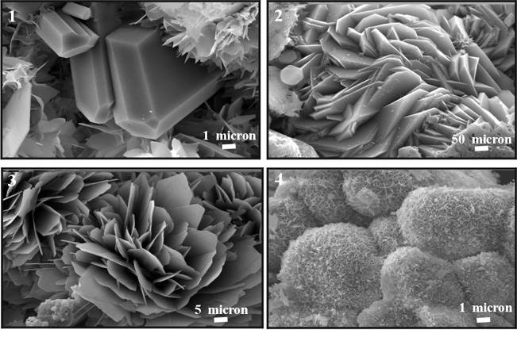
50 µm
2
Fig. 2 – a) Gypsum crystals on Brianyoungite of Su Zurfuru; b) Microspheres of Jarosite from Perda Niedda mine; c) Spheroid crystal aggregates of brianyoungite with laminar crystals of an unknown hydrated hydroxisulphate of Zn of Su Zurfuru mine ; d) Hydrozincite of Su Zurfuru.

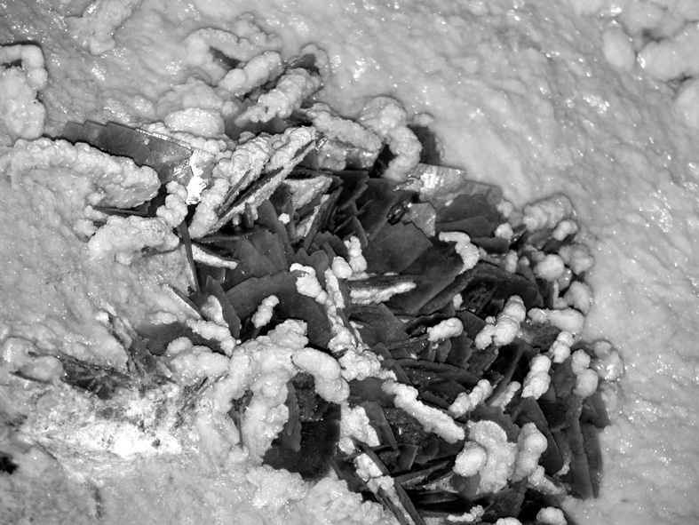
Also carbonates are very abundant, with the very well known cave minerals calcite, dolomite and aragonite, and metal carbonates such as cerussite, smithsonite and siderite, respectively of lead, zinc and iron. Less usual carbonates found in mine caves of south-west Sardinia are hydrozincite (found as tall stalactites and stalagmite floors in San Giovanni mine caves and as blue flowstone in Su Zurfuru mine) (Fig. 2 d) (Forti, 1985), aurichalcite (inside a blue aragonite coating in San Giovanni mine), and the very rare minerals gaspeite (coating small karstic voids in San Benedetto mine) (Cadoni et al., 1986) and phosgenite (well-known and very much appreciated mineral found in karst voids of Monteponi mine). Very rare is also ediphane, a calcium-lead chloride arsenate, found in the terra rossa of Santa Barbara cave (Forti et al., 2005c).

Fig. 3- Barite crystals covered with calcite in the Santa Barbara cave.
By oxidation processes of primary sulphide deposits, besides oxides and hydroxides also many sulphates are formed, e.g. barite, anglesite, gypsum, melanterite, chalcantite, epsomite and other more rare mineral species. Large beautiful barite crystals occurs extensively in the Santa Barbara cave system at San Giovanni mine where it coats floor, walls and ceiling of the cave, demonstrating a phreatic origin (Fig. 3) (Rossetti & Zucchini, 1957; Forti et al., 2005c). Other barite, in big crystals, has been described in mine caves of Barega (Naseddu, 1993). Beautiful anglesite crystals have been found in a small geode inside a drill core of a subacqueous cave cloud concretion in the Santa Barbara 2 cave (Forti et al., 2005c), and anglesite is also known from Monteponi mine caves. Gypsum is not as abundant as could be thought and has been reported only from Su Zurfuru and from Montevecchio mines. The scarce presence of gypsum in Sardinian mine caves is probably due to the fact that it is highly soluble. Melanterite and epsomite are ephemeral minerals that have been occasionally found in mine caves. Melanterite, together with its transient mineral species siderotile, copiapite and pisanite, have been reported from Genna Luas and from Montevecchio (Bini et al., 1986) while cotton like and bitter tasty epsomite flowers occurs seasonally in some caves not far from the entrances of the mine shafts and tunnels. The rare sulphates bianchite, bechererite and jarosite have been found respectively at Campo Pisano, Su Zurfuru and Perda Niedda. Bianchite at Campo Pisano covered the walls and ceilings of mine galleries in an area where evaporation of solutions with high concentration of sulphuric acid was enhanced by air currents. Bechererite and jarosite, instead, are metal sulphates formed by oxidation of sulphides under the presence of bacteria, respectively in a lead-zinc mine with minor quantities of copper and in an iron mine (Fig. 2 b).
Among the silicates formed in Sardinian mine caves kaolinite and allophane have been described from Santa Barbara and Perda Niedda respectively. Both could be of allochthonous origin, but given the acid and oxidising conditions of their environment it is not excluded that they formed inside the cave environment (Forti et al., 2005a, 2005c). The most extraordinary cave silicate of mine caves is hemimorphite, discovered in Su Zurfuru mine (Forti et al., 2005a), at Santa Lucia mine (Forti, 1985) and in Quarziti cave in San Giovanni mine (Forti et al., 1999). In the first two mines the mineral occurs as small flowstones blue in colour, while at San Giovanni mine hemimorphite forms a tall flowstone and some stalagmitic crusts (Forti et al., 1999). This mineral forms in these lead-zinc mines close to quartzite rocks and is related to the acid dissolution of the latter and subsequent deposition of the zinc-silicate. Hemimorphite often occurs together with opal, found as fine layers inside flowstones.

Conclusion
Sardinia has been one of the most important mining regions of Europe and industrial activities stopped only recently. Many ore deposits, especially in Southwest Sardinia, are hosted in dolostones and limestones of Cambrian age and thus mining activities have enabled to discover many mine caves, natural cavities that have no direct communication with the surface. These mine caves are “natural laboratories” in which many rare and interesting cave minerals can be found and recently some Italian research projects have enabled to discover several interesting mineral associations.
The scientific data obtained during these research projects will be of practical use for the individuation of the most important areas of scientific and/or didactical interest inside the Geomining Park of Sardinia, in order to protect and to valorise them. The short description of forty cave minerals already gives an idea of the importance of these mine caves from a mineralogical point of view, and future researches will surely allow to find other mineral species, enriching thus the already very long list of Sardinian cave minerals.

Acknowledgements
This research has been carried out in the framework of the Italian National Project PRIN 2002-2004 “Morphological and mineralogical study of speleothems for the reconstruction of particular karst environments” (Resp. Paolo Forti). The authors are indebted towards many cavers that have enabled the discovery of many cave minerals, and particularly Silvestro Papinuto and Angelo Naseddu of the Speleo Club Domusnovas. A special thanks also to Prof. Ilio Salvadori for his encouragement during our studies.

References
Bini A., Cadoni E., Forti P., Perna G. (1986) - La melanterite della miniera di Montevecchio nella Sardegna sud-occidentale. Notiziario di Mineralogia e Paleontologia 48, pp. 7-13.
Bini A., Cremaschi M., Forti P., Perna G. (1988) - Paleokarstic fills in Iglesiente (Sardinia, Italy): sedimentary processes and age. Annales Societé Géologique Belgique 111, pp. 149-161.
Cadoni E., Forti P., Perna G. (1986) - La gaspeite magnesifera della miniera di S.Benedetto (Ca). Rivista Mineralogica Italiana 2, pp. 62-67.
Cervellati R., Forti P., Zavatti R. (1971) - L'aragonite azzurra sarda. Speleologia Emiliana 3(7), pp. 43-60.
Chiesi M., Forti P. (1987) - Studio morfologico di due nuove cavità carsiche dell'Inglesiente (Sardegna sud occidentale). Ipoantropo 4, pp. 40-45.
Civita M., Cocozza T., Forti P., Perna G., Turi B. (1980) - Hydrogeology and geochemistry of groundwater in the mining district of Iglesias (South-Western Sardinia) and its correlation with the speleogenesis and cave mineralizations. Proceedings of the European Regional Conference on Speleology, Sofia, Bulgaria 2, pp. 467-474.
Civita M., Cocozza T., Forti P., Perna G., Turi B. (1983) - L'idrogeologia del bacino minerario dell'Iglesiente. Memorie dell’Istituto Italiano di Speleologia, Serie 2, 2, 137 p.
Cortecci G., Fontes J-C., Maiorani A., Perna G., Pintus E., Turi B. (1989) - Oxygen, sulfur, and strontium isotope and fluidi inclusion studies of barite deposits from the Iglesiente-Sulcis mining district, Southwestern Sardinia, Italy. Mineral. Deposita 24, pp. 34-42.
De Vivo B., Maiorani A., Perna G., Turi B. (1987) - Fluid inclusion and stable isotope studies of Calcite, Quartz and Barite from karstic caves in the Masua mine, Southwestern Sardinia, Italy. Chemische Erde 46, pp. 259-273.
De Waele J., Forti P., Naseddu A. (1999) - Le "Grotte di Miniera": patrimonio scientifico e risorsa turistica. In Atti del Convegno Internazionale di Studio "Paesaggio Minerario"- Cagliari, 7-10 Ottobre 1999.
De Waele J., Forti P., Perna G. (2001) - Hyperkarstic phenomena in the Iglesiente mining district (SW-Sardinia). In "Water-Rock Interaction 2001", R. Cidu (Ed.), A.A.Balkema Publishers, Lisse: 619-622.
De Waele J., Messina M., Naseddu A., Papinuto S., Sanna F., Sotgia S. (2003) - Le grotte di miniera in Sardegna. Anthèo (Bollettino del Gruppo Speleo-Archeologico “Giovanni Spano” Cagliari) 7: 46-52.
De Waele J., Frau F. (2005) - Le grotte di miniera nelle aree del Parco Geominerario Storico ed Ambientale della Sardegna. Memorie dell’Istituto Italiano di Speleologia (in print)
De Waele J., Frau F., Forti P., Galli E., Rossi A. (2004a) - The scientific and didactic importance of the mine caves of Mount San Giovanni (Southwest Sardinia, Italy). 32nd IGC, Florence, August 20-28 2004, Abstract Vol. 2: 1015.
De Waele J., Forti P., Frau F., Galli E., Naseddu A., Rossi A. (2004b) - Le grotte di miniera del Monte San Giovanni (Iglesiente, Sardegna sud-occidentale): una risorsa scientifica e turistica di inestimabile valore. Atti del II Convegno Nazionale “Geologia e Turismo”, Bologna, 3-4 Novembre 2004: 106-108.
Fabbri M., Forti P. (1981) - Esplorazioni nell'Iglesiente. Sottoterra 59, pp. 31-35.
Fabbri M., Forti P. (1986) - Recenti esplorazioni nelle miniere dell'Iglesiente (Sardegna sud occidentale). Sottoterra 74, pp. 20-28.
Forti P. (1983) - I minerali di grotta. Speleo 9, pp. 9-24.
Forti P. (1985) - Alcuni nuovi minerali carsici dell'Iglesiente. Notiziario di Mineralogia e Paleontologia 44, pp. 3-10.
Forti P. (2005) - L’importanza scientifica delle grotte di miniera. Memorie dell’Istituto Italiano di Speleologia (in print)
Forti P., Galli E., Rossi A., Naseddu A. (2005a) - Studio mineralogico di una concrezione della Fontana dello Zinco (Miniera di Su Zurfuru, Fluminimaggiore) e dati preliminari su analoghe concrezioni della Miniera di Perda Niedda (Iglesias). Memorie dell’Istituto Italiano di Speleologia (in print)
Forti P., Messina M., Naseddu A., Papinuto S., Sanna F., Sotgia S. (1999) - Emimorfite in una "grotta di miniera" Gonnesa-Sardegna. Speleologia 41, pp. 61-68.
Forti P., Pagliara A., Galli E., Rossi A., De Waele J., Borsato A., Zanchetta G., Shopov Y. (2005b) - Santa Barbara cave (Sardinia, Italy): some hundred million years of development as recorded in speleothems. Geophysical Research Abstracts, 7, 01160
Forti P., Pagliara A., Galli E., Rossi A., De Waele J., Naseddu A., Papinuto S. (2005c) - Studio morfologico e mineralogico di dettaglio del concrezionamento del sistema carsico di Santa Barbara (Miniera di San Giovanni, Iglesias). Memorie dell’Istituto Italiano di Speleologia (in print)
Forti P., Perna G. (1981) - La turisticizzazione della Grotta di Santa Barbara nella Miniera di San Giovanni e la creazione di un Museo Minerario ad essa connesso (Iglesias-Sardegna sud occidentale). Le Grotte d'Italia 4(10), pp. 181-187.
Forti P., Perna G. (1982a) - L'area speleologica dell'Iglesiente: carsismo e speleogenesi. Memorie dell'Istituto Italiano di Speleologia 2(1), pp. 27-34.
Forti P., Perna G. (1982b) - Orientazione dei cristalli di calcite nelle crevasse della Miniera di Nebida (Sardegna sud occidentale). Periodico di Mineralogia 51(2), pp. 155-160.
Forti P., Perna G. (1982c) - Studio morfologico e genetico delle pisoliti di aragonite rinvenute in due gallerie minerarie presso Iglesias (Sardegna SW). Atti del XIV Congresso Nazionale di Speleologia, Bologna, 2-5 settembre 1982, pp. 407-419.
Forti P., Perna G. (1982d) - Concrezioni e cristallizzazioni nei karst dell'Iglesiente (Sardegna SW). Atti del XIV Congresso Nazionale di Speleologia, Bologna, 2-5 settembre 1982, pp. 421-430.
Forti P., Perna G. (1983) - Studio morfologico e genetico delle pisoliti di aragonite rinvenute in due gallerie minerarie presso Iglesias (Sardegna SW). Sottoterra 64, pp. 18-30.
Forti P., Perna G. (1986) - L'ipercarsismo con particolare riguardo all'Iglesiente (Sardegna Sud Occidentale). Natura Alpina 36 (2-3), pp. 85-100.
Forti P., Perna G. (1988). Genesi della monteponite di Monteponi. Riv. It. Min. 1: 45-51.
Forti P., Perna G., Turi B. (1981) - Genetical observations on some natural cavities of the Masua mines (SW Sardinia). Atti del VIII Congresso Internazionale di Speleologia, Bowling Green 1981, pp. 779-780.
Hill C., Forti P. (1997) - Cave minerals of the World. National Speleological Society, Huntsville, 463 p.
Ludwig K.R., Vollmer R., Turi B., Simmons K.R., Perna G. (1989) - Isotopic constraints on the genesis of base-metal ores in southern and central Sardinia. European Journal of Mineralogy 1, pp. 657-666.
Naseddu A. (1993) - Grotte in miniera. Sardegna Speleologica 3, pp. 8-14.
Rossetti V., Zucchini A. (1957) - Baritina della grotta di Santa Barbara. Rendiconti Seminario Facoltà Scienze Università di Cagliari 26(3-4), pp. 240-255.
Uras I. (1957) - Su una cerussite stalattitica della Miniera di Arenas. Resoconti dell’Associazione Mineraria Sarda 61(5-6), pp. 5-12.

