Temporal earthpyramids in caves.

An example from Zesta Nera cave of Sidirokastro, Serres (Macedonia, Greece)

by
Lazaridis Georgios, Vavliakis Eleftherios & Pennos Christos
School of Geology, Aristotle University (A.U. TH.), 54 124 Thessaloniki, Macedonia, greece

Abstract

Zesta Nera cave is located in the Krousovitis Basin, where the homonymous river is flowing, in the region of Sidirokastro town (prefecture of Serres). The region geologically belongs to the Rhodope massif. The cave is a travertine bridge of 130m in length. In the cave sediments, conical formations made by sand deposits, covered by pebbles, were noticed. These formations are usually reported outside of the caves and they are called earthpyramids. In the present paper, the conditions and the process of their creation inside the Zesta Nera cave are analyzed.

Introduction - Geological setting
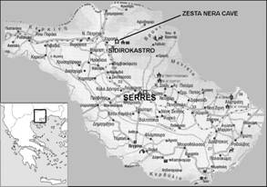
At the northern region of Serres prefecture, in central Macedonia (Greece), close the town of Sidirokastro (Fig. 1) a number of caves have been recorded (Lazaridis, unpubl. data) in the Krousovitis basin, since 2001. In particular, the systematic cave exploration began in 2001, by members of the department of Northern Greece of the Hellenic speleological society. In 2002, researchers of the School of Geology of Aristotle University (Thessaloniki) continued the study of the area by a project sponsored by the Serres Prefecture.

The Krousovitis basin strikes NE-SW and intervals the mountains of Orvilos, Angistron and Vrondou. This basin is filled with Neogene and Quaternary sediments (Karystinaios, 1984, Papaphilippou-Pennou, 2004) that rest onto a pre-alpine and alpine basement that belongs to Pangeon Unit of the Rhodope massif (Mountrakis, 1985). This basement mainly consists of crystalline rocks such as gneisses and marbles, as well as large granitoid bodies of Tertiary age that intruded into the former, such as the well-known Vrondou granitoid.
Figure 1. Map of Greece with the Serres Prefecture and the location of Zesta Nera Cave depicted

The older sediments in the basin are from the Neogene period, deposited in lakes or from rivers. These depositions are mainly conglomerates, sandstones and marls, where sometimes lignites are interposed. The Pleistocene sediments include brecciaed marbles (olistholiths) and travertines. Olistholiths came from the northern part of the basin as result from the glacial periods of Pleistocene (Sotiriadis, 1966). The travertines are deposited in small lakes or cascades. At the south part of the Krousovitis basin holocainic depositions appear.

In the central part of the basin there are hills of low altitude. The olistholiths show a characteristic view in the area because they are more resistant to erosion and they occur on the hilltops. Streams terminating in the krousovitis river have N-S direction and they are of a V shape (in cross sections) by down-cutting.

Various types of caves have been distinguished, according to their lithology and development. The most interesting cave of the area is that formed by travertine deposits and belongs to the cave category that is well known as Travertine Bridge. This natural bridge (Zesta Nera cave) is created in Zesta Nera area, above the Krousovitis River and is the unique reference in Greece.

Zesta Nera area is located 2 km NE far from Sidirokastro, close to the Mavros Vrachos hill. The name Zesta Nera (=warm waters) derives from a thermal spring, which appears there. The deposition of the travertine is due to the calcite-saturated water of this spring. The main research is focused in the travertine bridge, where special formations in the cave sediments were observed, formed by the drip water erosion after the deposition of the sediments. This phenomenon always takes place after every new deposition followed by erosion.

Morphology of the Zesta Nera cave
Zesta Nera is a SW-NE striking cave with two entrances, four chambers and of length about 130 m. The river enters the cave from the SW entrance and outflows from the NE entrance. The height of the cave ranges from 0,5 to 12 m and the breadth from 0,5 to 15 m. The chambers are connected by small passages. Most of the passages are short and wide except the last one at the NE part, which is high and narrow (Fig. 2).

Along the river into the cave brecciaed marble (olistholiths) at the lower parts of the sidewalls and travertine at the higher ones were observed. Sediments from the river cover the floor of the cave. In the chambers, sometimes there are places where terraces are formed by sediments.

At the entrances of the cave there are two cascades about 15 m of height. The water comes from the thermal spring of the area and deposits the travertine, in which the cave is formed. An uplifting of the basin is the main fact at the beginning of the speleogenesis. After this, an intensive down-cutting resulted in a narrow valley with height difference between Krousovitis River and the stream derived from the thermal spring. The first cascades that deposit travertines up to now were formed in the area as consequence. The deposition started close to the spring and by the time it was forwarded to Krousovitis River. After the formation of a travertine bridge over the river, the deposition along the valley resulted in lateral extension of the cave up to the length of 130m.

Travertine bridges are rare landforms with few references all over the world. Two well-known cases described by Bayari (2002) are referred in Turkey. Bayari concludes that the major factors were lead to the formation of these natural bridges, are the height of calcite-saturated springs above river level and the width of the valley section. He also mentions that the lateral distance that can be accessed by a travertine rim depends on the tensile strength and the grain density of the travertine.

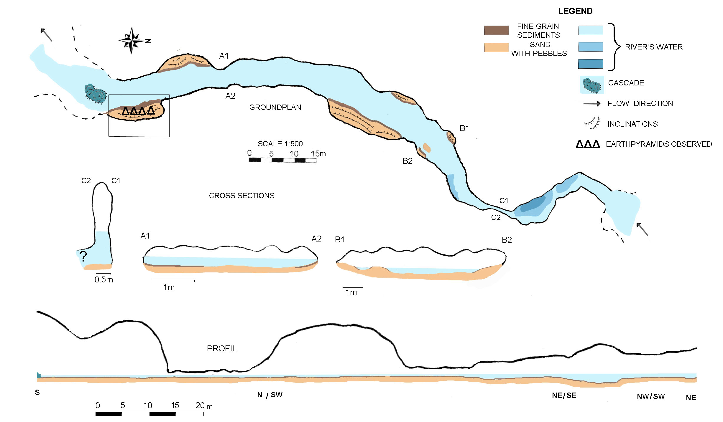
Figure 2. Ground plan, cross sections and profil of the Zesta Nera cave (Sidirokastro, Macedonia, Greece). The place where earthpyramids have been observed is also depicted.

Special forms in the sediments of Zesta Nera cave
In some places in the cave when the river flow is normal, there are sediments higher than its level deposited as terraces. One of these terraces is located at the east side of the first south chamber of Zesta Nera cave. In over-flow conditions, the deposition in this place can overpass the two meters of height. At this side of the river, mainly sand with few pebbles is deposited. Opposite, at the west side of the chamber, pebbles are mainly deposited, in over-flow cases. The east side is more interesting because after the over flow event, the erosion gives special formations on the sediments that are not cemented. These formations were formed by the same sediment (silty-sand), and they have a conical shape. It is notable that on their top there is always one pebble. The sections parallel to their base follow the shape of the pebble on their top (Fig. 3b).

The formations appear only where water drips from the ceiling that is 12 m high. Drip water erodes the sand very fast in contrast to the erosion of the pebbles. This water derives either from the thermal spring or from the rain and comes in the cave trough the travertine’s porosity. In this way there is dripwater in the chamber during the year, almost independent from the rainfalls. The drip water can take volumes between 2,5 ml/(min x cm²) or less and 12,6 ml/(min x cm²).

At the beginning small holes on the sediment’s surface are made by the drip water (Fig. 3a). Afterwards the erosion builds up these formations by the removal of the sand (Fig. 3b). The pebbles protect the sediment below them from the drip water erosion. Usually their dimensions are less than 20 cm high and 10 cm wide, mainly depended on the thickness of the sediment, on the surface’s inclination and on the pebble’s dimensions.
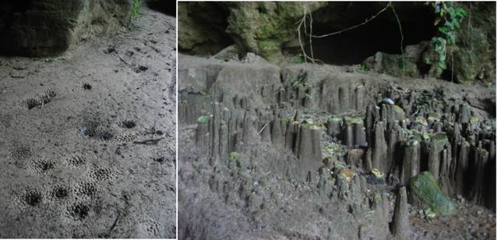
a b
Figure 3. Earthpyramids from Zesta Nera cave: a) Initial stage of their formation in places where the water drips.
b) A group of them formed on the sedimentary floor of the cave.

The development of these formations is very fast. They can be formed in some days after the over flow fact while their initial creation starts immediately after the deposition. On the other hand, their destruction is fast too. They have a lifetime span between two over flow events and they can be described as a temporally and repeating phenomenon.

Similar formations, known from outside sediments of the caves, are called earthpyramids. These are erosional formations with conical or column-like shape, made by sediment with a pebble on their top. Their formation is due to the erosion by rainwater of not cemented sediments like moraines, rich in pebbles and blocks (Becker, 1966, Dorrenhaus, 1966). The creation of the earthpyramids is easier in inclinational slopes. During the erosional activity in the area, earthpyramids have been formed up to their complete destruction.

Some formations by mud or sand are also the “sandsicles”, formed when a high proportion of sand, silt or dust in flowstone or dripstone, produces sharply pointed ends, somewhat like the denticle of a saw blade. Other formations are composed almost entirely of mud, sand, detritus and organic matter. The most common of these are mud and sand stalagmites, as well as mud or sand stalactites, flowstone draperies, columns etc. In most of the situations calcareous material cements together the sand grains (Hill & Forti, 1997).

The formations in the sediments of Zesta Nera cave are earthpyramids created by erosion but in a different way that allows their development to be repeated. In contrast to the other sand and mud formations in caves the earthpyramids of Zesta Nera cave, have different morphology and they aren’t cemented.

Conclusions
The Zesta Nera cave is attributed to a “travertine bridge” and this landform is described for first time in Greece. It must be noted that the travertine bridges can be considered as rare landforms, with few references all over the world.

At the south entrance of the Zesta Nera cave, sand formations were observed and they have been described as earthpyramids. It is also the first time that these erosional formations are referred into a cave of Greece, in contrast to the typical earthpyramids that are described always as a formation outside of the caves.

The earthpyramids of the Zesta Nera cave are temporal and they can be characterized by a procedure with a repeating character. This character is due to the alternation of a) the deposition that is realized during overflow events, which have continuous succession and b) the meanwhiles of the erosion of the sediments by the dripwater.

References
BAYARI, C.S., 2002. A rare landform: Yercopru travertine bridges in the Taurids karst range, Turkey.- Earth Surf. Process. Landforms 27: 577-599.
BECKER, H., 1966. Vergleichende Betrachtung der Entstebung von Erdpyramiden in verschiedenen Klimagebieten der Erde.- Kolner Geogr. Arbeiten. In: Westermann Lexicon der Geographie 1972, ISBN 3-14-164011-7, 1: 938.
DORRENHAUS, F., 1966. Der Ritten und seine Erdpyramiden.- Kolner Geogr. Arbeiten. In: Westermann Lexicon der Geographie 1972, ISBN 3-14-164011-7, 1: 938.
HILL, C. & FORTI, P., 1997. Cave Minerals of the World.- 2nd edition, National Speleological Society. Huntsville, Alabama, p. 465, USA..
Karystinaios, Ν. 1984. Palaeogeographical evolution of Serres basin. Lithostratigraphy, Biostratigraphy and tectonic.- Ph.D. Thesis, University of Thessaloniki, p. 1-230 (in Greek).
LAZARIDIS, G., 2004. Study of the caves of the Krousovitis River Basin, Serres.- Unpublished study submitted in School of Geology, Aristotle University, 1-62, Thessaloniki (in Greek).
Mountrakis, D, 1985. Geology of Greece.- p. 1-207, School of Geology, Aristotle University, Thessaloniki (in Greek).
Sotiriadis, L, 1966. Morphological research in the Krousovitis Basin close to Sidirokastro. Ph.D. Thesis, Sci. Annals., Fac. Sciences, 10: 1-62, Aristotle University of Thessaloniki, (in Greek).
Papaphilippou- Pennou E., 2004. dynamic evolution and recent exogenic processes of strymon River network in Serres graben (North Greece). Ph.D. Thesis, University of Thessaloniki (in Greek with extended English abstract).

