Megalon Eptamilon cave (Serres, Macedonia, Greece)
Speleogenesis and development
by
Pennos Christos, Vavliakis Eleftherios & Lazaridis Georgios
School of Geology, Aristotle University (A.U. TH.), 54 124 Thessaloniki, Macedonia, greece

Abstract
In the present study the Megalon Eptamilon cave is described and geological observations in relation to its speleogenesis and development are discussed. It is located at the foothills of the Menikio Mountain, in the county of Serres (Macedonia, Greece). The region belongs to the Pangeon unit of the Rila - Rhodope massif. The Megalon Eptamilon Cave is a system of karstic tubes and the development follows the main tectonic structure of the region. It has two (2) different directions of development, perpendicular between them. One has NE-SW and the other NW-SE direction. The corridors of the cave have two different shapes, according to their bearing. The NE-SW corridors are low and wide, while the NW-SE ones are high and narrow.

Introduction
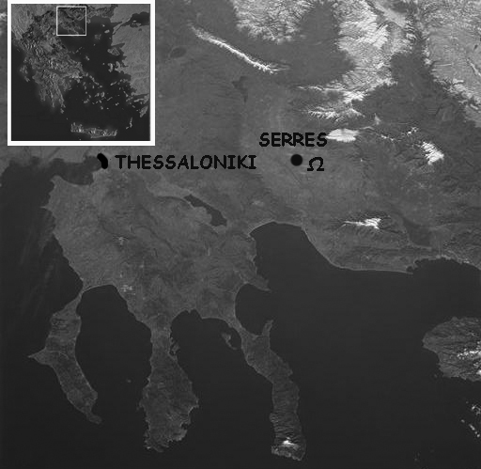
The Megalon Eptamilon Cave (MEC) is located at the foothills of Menikio Mt., close to Eptamili village, 3Km from Serres, Prefecture of Serres (Macedonia, N. Greece) (fig. 1). The cave was discovered in 1965 during the works at an old marble quarry. In the same year, the first exploration took place by members of the Hellenic Speleological Society (H.S.S.), the head of which was the speleologist †I. Ioannou.

Geological settings
The cave has been formed in Paleozoic marbles that belong to the Pangeon Unit of the Rhodope massif (Kilias & Mountrakis 1990). At the region acts a 10-km-fault segment of the Serres Fault Zone, which consists of sub-parallel E-W striking faults that dip at high to very high angles to the S controlling the deposition of the Quaternary sediments up to the Late Pleistocene-Holocene fan deposits (Tranos & Mountrakis 2004) (fig. 2).
Figure 1. Map showing where Megalon Eptamilon cave is located.

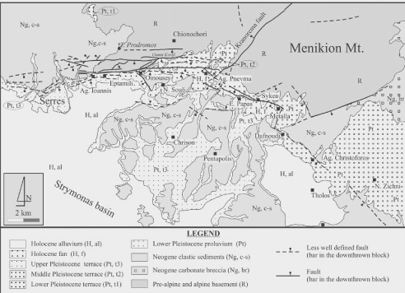
Ω
Figure 2. Geological map of the region of Serres (Tranos & Mountrakis 2004) with the Megalon Eptamilon cave (Ω) depicted.

Geomorphological setting
At Menikio mt. there were recognized four (4) uplifting movements by Vavliakis (1981), which developed equal Pediments and Glacis. These landforms have been formed between middle Miocene to middle Pliocene (Psilovikos, 1986). MEC has been formed on a Glacis surface, because of the action of Quaternary (Pleistocene) faults that acted at the region (Papaphilippou – Pennou, 2004).

Megalon Eptamilon Cave
Megalon Eptamilon Cave (MEC) is a system of karstic tubes of NE-SW direction that communicate with NW-SE passages. The total length of the passages of the cave is about 700m (fig. 3) (Pennos, unpubl. data).
In the cave there are various speleothemes such as stalactites, stalagmites, draperies and flowstones. During the research in the cave, few coprolites of a large carnivore were found. The size and shape, in comparison with those found in the Agios Georgios Cave, allow them to be attributed to the spotted cave hyaena [Crocuta crocuta spelaea (goldfuss 1832), Tsoukala, pers. com.]. Crocuta crocuta spelaea lived in Europe during the Late Pleistocene, so it can be concluded that at those period the cave may probably have a different entrance from the present one that was opened during the works at the quarry.

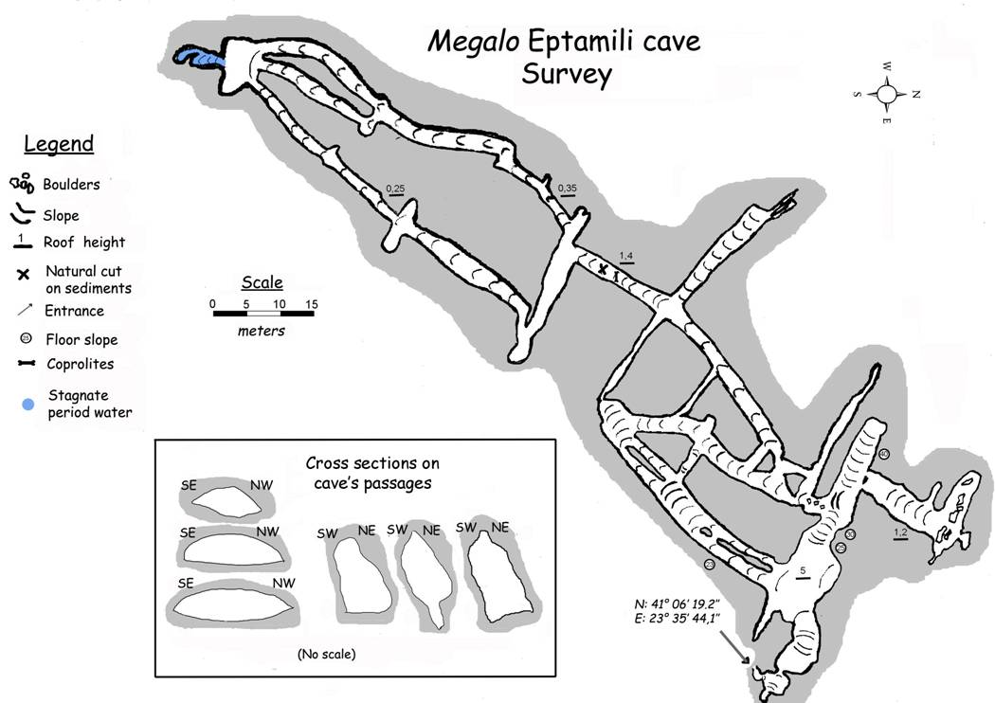
Speleogenesis and Development
Megalon Eptamilon cave survey
Figure 3. Megalon Eptamilon Cave Survey.

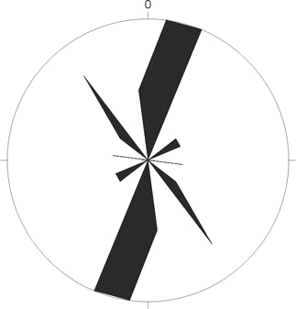
Megalon Eptamilon Cave is a system of karstic tubes developed at the phreatic stage. In the present day the cave system is dry in the vadose zone. During the speleogenesis at the phreatic stage, two main groups of passages, perpendicular between them, are formed along NE-SW and NW-SE directions. The shape of the passages depends upon the directions they follow. The passages which have NE-SW direction are low and wide (fig. 5), in contrast with the others that follow NW-SE directions and they are high and narrow (fig. 6). In the former case the passages follow the crossing between the bending and the NE-SW joints. In the latter case passages are developed along the other group of joints of NW-SE striking. The water is flowed to the local basic level mainly through the NW-SE passages.

Afterwards, the cave passes to the vadose zone, when the local basic level had changed. The hypothetical shape of a phreatic passage along an almost vertical joint as these with the NW-SE striking, it can’t compare with the shapes observed in these passages. This is due to the condensation inside the cave and, mainly, to the continuous collapses when the cave passed to the vadose zone. The speleothemes of the cave has been also formed during this stage.

The geometry of the discontinuities of the marbles is responsible for these collapses. The inclination of the marbles and the joints of NW-SE striking are the main discontinuities. The passages are becoming wider and higher because of the collapsed blocks from the SW sidewalls (fig. 7 & 8). These blocks are deposited at the floor of these passages as an ellouvial cone of debris.
Figure 4. Joints plane from the outside area of the Megalon Eptamilon cave

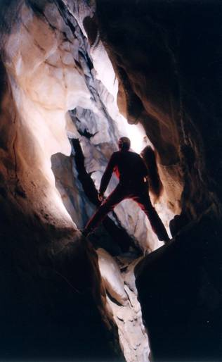
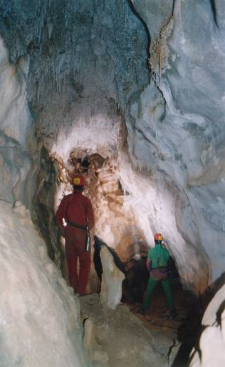
Figure 5. Megalon Eptamilon Cave: Passages of NE-SW direction.

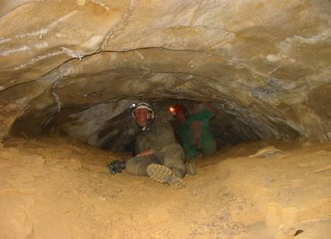
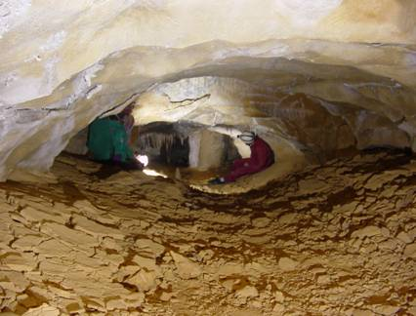
Figure 6. Megalon Eptamilon Cave: Passages of NW-SE direction.

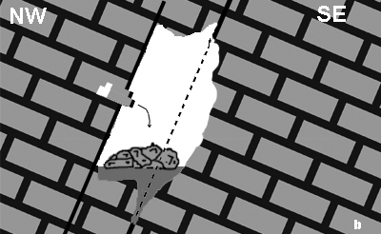
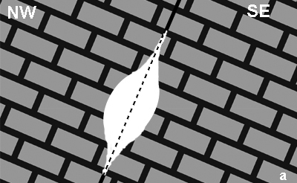
Figure 7. Megalon Eptamilon Cave: Development of passages of NW-SE direction.
- Their shape at phreatic phase, b) their shape at vadose zone. Collapses mainly result in the morphology of the NW sidewalls. In contrast, the SE sidewalls are formed mainly by condensation.

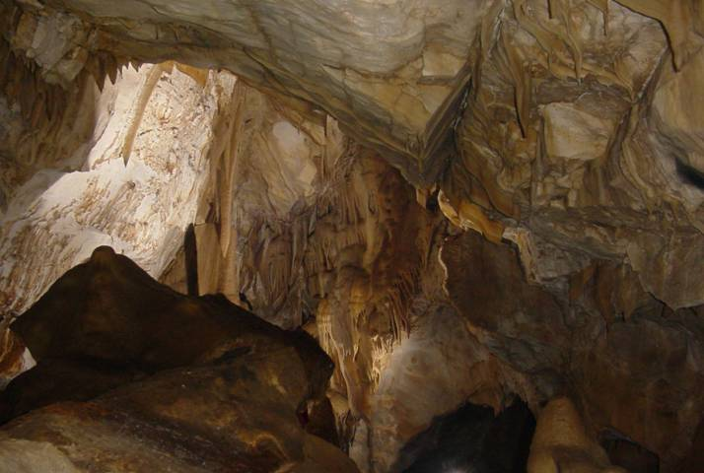
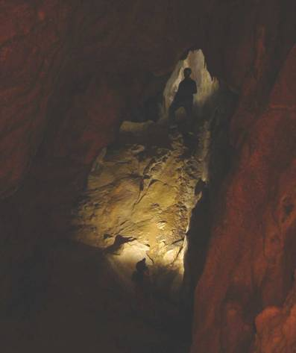
a
b
collapsed blocks
NE
SW
NE
SW
Figure 8. Megalon Eptamilon Cave: Passages of NW-SE direction of early (a) and older (b) stage.

Conclusions
- The Megalon Eptamilon cave has been developed at a Glacis during the Pleistocene age.
- The cave has also been developed at the phreatic phase and then passed at the vadose zone.
- The ne-sw striking passages were developed during the phreatic phase along the crossing between the discontinuities, which derive from the bending and from one of the joint systems, giving them a circular shape.
- The NW-SE striking passages created at the phreatic stage along almost vertical joints, but their present shape was developed in the vadose zone by condensation and collapses.
- The bending and the joints of the marbles lead the collapses. The low angle of the bending, as well as the high dip joints in respect to their striking contribute to the collapse process.

Acknowledgements
The authors would like to thank the speleologists of the Department of Northern Greece of the Hellenic Speleological Society, V. Makridis, I. Partsios, G. Sotiriadis, S. Zachariadis, K. Polydoropoulos, H. Garlaouni, and S. Pappa for their help during the numerous visits at Megalon Eptamilon Cave. We would also like to thank Assist. Prof. E. Tsoukala for her help, and N. Tsiakmakis for his linguistic advice.

References
Vavliakis, Ε., 1981. Morphologische und morphogenetische Untersuchungen der Abtrgungsflächen, Karstformen, Glazial und Periglazialformen des Gebirges von Menikion.- Ph.D. Thesis, School of Sciences, University of Thessaloniki (in Greek).
Kilias, A. & Mountrakis, D. 1990. Kinematics of the crystalline sequences in the western Rhodope massif.- Geologica Rhodopica, 2: 100-116.
Papaphilippou- Pennou, E., 2004. dynamic evolution and recent exogenic processes of strymon river network in serres graben (North Greece).- Ph.D. Thesis, School of Geology, University of Thessaloniki (in Greek with extended English abstract).
Pennos, Ch., 2004. Study of karstic landforms of Eptamilon, Serres.- Unpublished study submitted in School of Geology, Aristotle University, 1-39, Thessaloniki (in Greek).
Psilovikos, A., 1986. Contribution to the Geomorphology of the South-West part of the Rhodope Massif.- Geolog. Balk, 44: 55-87.
Tranos, M.D. & Mountrakis, D.M., 2004. The Serres fault zone (SZF): an active fault zone in Eastern Macedonia (Northern Greece).- Proceedings of 5th International Symposium on Eastern Mediterranean Geology, 2: 892-895, Thessaloniki.

